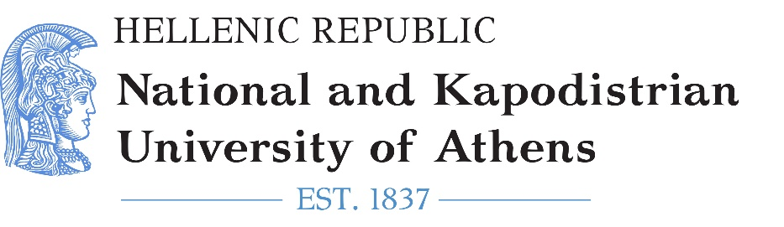
SCHOOL OF ECONOMICS AND POLITICAL SCIENCES
DEPARTMENT OF POLITICAL SCIENCE AND PUBLIC ADMINISTRATION
Master’s Programme in “Southeast European Studies: Politics, History, Economics”

MASTER'S DEGREE THESIS:
TITLE

Supervisor: Student:

YEAR

